**Deep Learning Lab – 4**

|  |  |  |
| --- | --- | --- |
| Score threshold | IoU threshold | Cars detected |
| 0.30 | 0.45 | 1 |
| 0.60 | 0.45 | 0 |
| 0.90 | 0.45 | 0 |
| 0.30 | 0.75 | 1 |
| 0.60 | 0.75 | 0 |
| 0.90 | 0.75 | 0 |

**Interpretation**

1. When the confidence threshold is low (0.30), YOLO detects a car even with low certainty.
2. Increasing the confidence threshold to 0.60 or 0.90 eliminates detections because the model isn’t confident enough.
3. Changing the IoU threshold (0.45 → 0.75) didn’t change much because there was only one car, so overlapping boxes weren’t an issue.

Lower confidence thresholds allow YOLO to detect objects even if it’s not very sure, increasing recall but risking false positives. Higher confidence thresholds make the model stricter, improving precision but sometimes missing objects entirely. IoU threshold changes had little effect here because there was only one object, but in images with multiple overlapping objects, a higher IoU would keep more overlapping boxes.

**Advanced Task 1: Class-wise Filtering and Comparison**

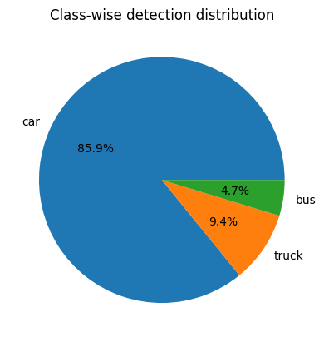

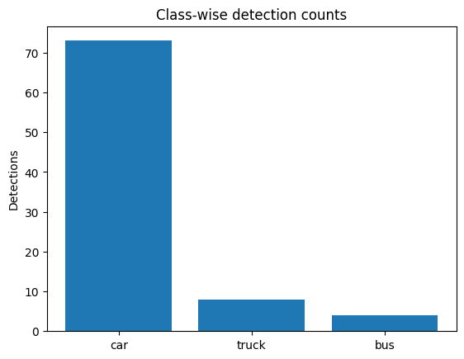

**Results**

In our dataset, the model detects cars much more frequently and reliably compared to other classes like trucks or buses. This suggests that the dataset or model is more optimized for detecting cars, while detections for people and motorcycles are relatively sparse.

**Advanced Task 2: Threshold Sweep with Detection Counts**

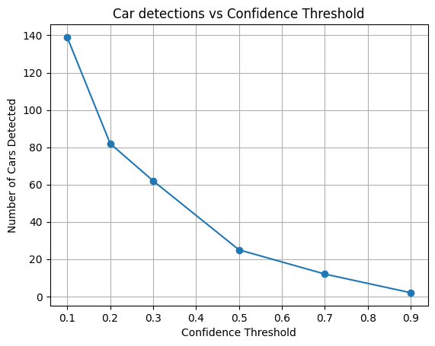

In this dataset, the sweet spot is around 0.3–0.5 confidence, where the model balances capturing enough cars while reducing false positives.